Ranario, Peter Cruz R.  
IT26A DML  
  
INSERT  
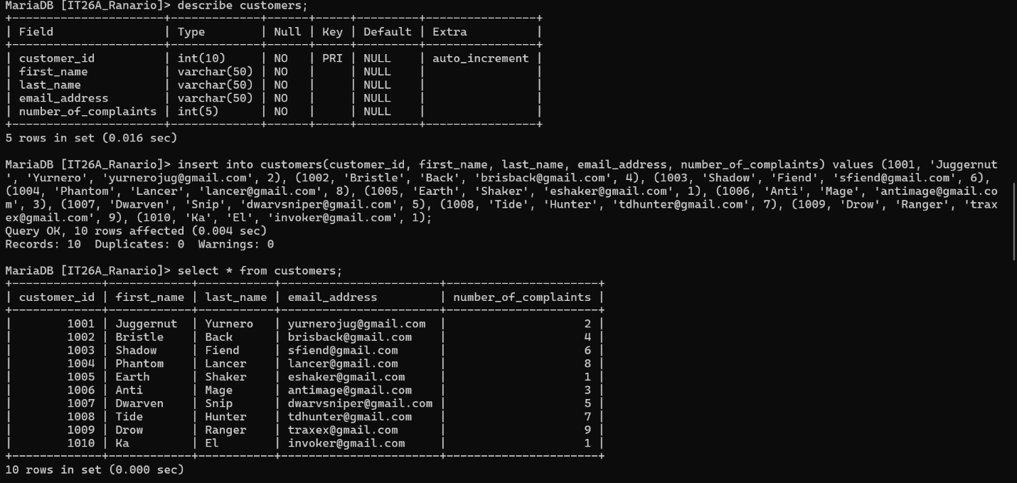

SELECT

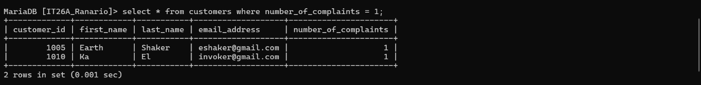

UPDATE

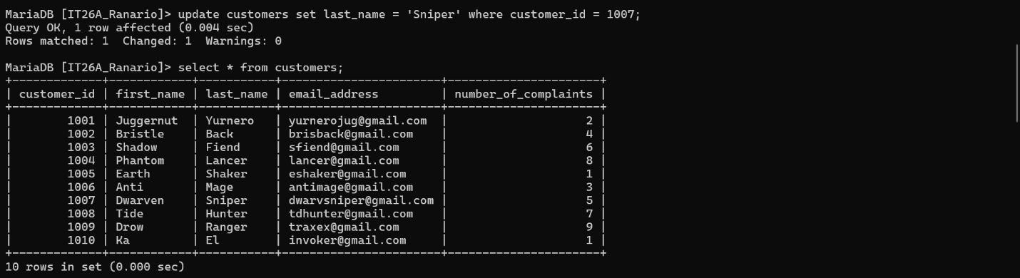

DELETE

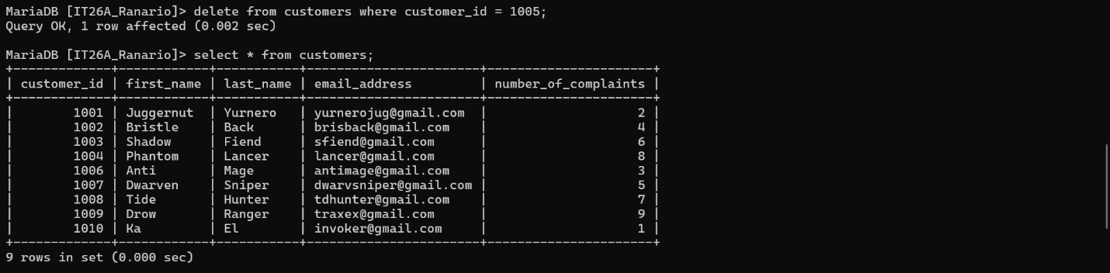

CASCADE

Ma’am, I haven't performed the cascading command since it was already set in the database. For that, when I will be updating or deleting a row from the parent table which is the customers table, the corresponding rows in the child table which is the sales are automatically being updated or removed.

